Tour code: Hatyai 4day3night (HTY-04)
Tour highlight: Khlong Hae Floating Market/ Samila Beach/ Songkhla Old Town
Complementary one drink coconut ice cream or Thai Tea
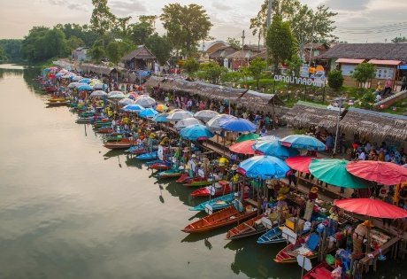
DAY 01 Flight arrive to Hatyai (meal by own)
Assemble at airport for flight to Hatyai , meet and great and transfer hotel check in ,
- Visit Khlong Hae Floating Market (Open Fri, SAT and Sunday only) or Asean Market

DAY 02 Hatyai - Songkhla - Hatyai (Breakfast / L)
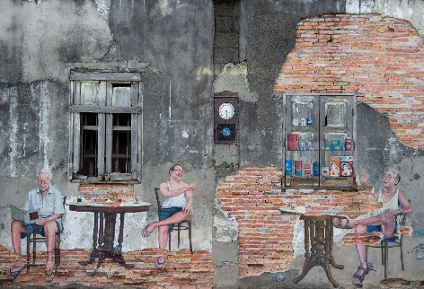
- Breakfast at hotel restaurant
- Transfer to Wat Khok Samun Khun (traditional attire by own cost)
- Transfer to Songkhla
- Lunch at Samila Beach & Seafood (Bung Sem Seafood) or Mahadsajan Ko Yo Seafood
- Visit Songkhla Old Town, Tanggok Bridge
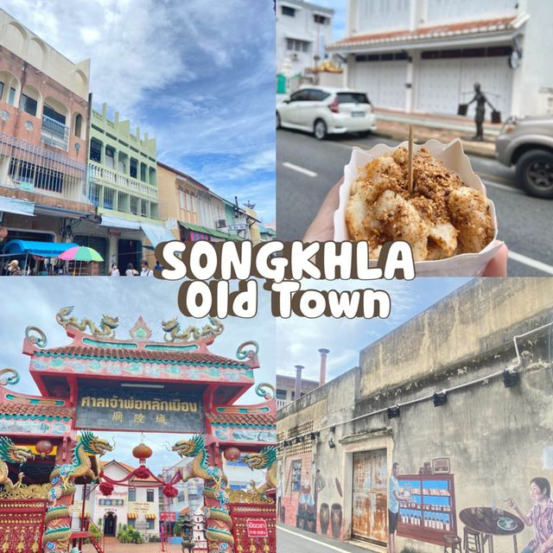
- Transfer back to Hatyai & Street Food

DAY 03 Hatyai (Breakfast)
- Breakfast at hotel restaurant
- Free and Easy
(No guide & No transport standby)

DAY 04 Hatyai- Departure (Breakfast)
- Breakfast at hotel restaurant
- to airport for your flight. Bringing back wonderful

